Individualized Learning Project
Education Technology
Jacob Newton
University of Alaska Southeast

As we speed our way into the 21st century, technology is more and more at the forefront of all of our lives. Children especially are very connected to technology. With social media, games and entertainment students seem to engage greatly with anything related to technology. I believe it is very important to integrate these technologies into our classrooms.
For my individualized learning project I would like to learn more about use of online quiz and polling sites such as polleverywhere, socrative and Kahoot. I have yet to try implementing this technology into my classes and feel that students would respond greatly to it. My hopes are that I can do reviews for tests/quizzes though a fun interactive quiz online. I plan to allow students to use their phones, Ipads, Itouches or other internet compatible devices to participate.
Objective: To create a fun and interactive review for a Quiz that uses Kahoot.com.
Activities: Students will use a smart device of their choice to participate in this activity. I feel since they are typically not allowed to have their phones in class they will choose to use them if they have them. I will also provide our Microsoft surface tablets for students who need them. My hopes is that the level of engagement will be high thus creating deeper levels of understanding with the content.
Day 1: Students will enter the class and here music playing to signify that we are taking a Kahoot quiz. All students will be reminded the day prior to the quiz to bring their smart devices if they choose. Students can use a Microsoft Surface tablet if they do not have their own device. Once given instructions to log in, the students will log in, create a school appropriate nickname and prepare for the fun! This quiz will be used as a review for the content we are currently learning. Homework for the evening will be to study the content and prepare for the real quiz tomorrow.
Day 2: The scene will be the same, yet the students will think they are going to be working on an old-fashioned paper style quiz. I will break the news to them that if they studied and remember the review from yesterday, that the quiz is going to be the same. My intensions are to create a deeper understanding for all students through interactive teaching methods. With all students engaged it sets the stage for real learning to take place.
Assessment Day 1: I will look at the success of the activity through formative assessment mainly. Student’s reactions, their feedback and engagement will be my main focus. The content and scores from the website will also be a part of the assessment of how well the students received the lesson.
Assessment Day 2: Today will be the summative assessment for the Chapter 4 quiz. The quiz will be worth 25 points and will be weighted as 25% of their final grade. Information will be stored to my Kahoot account and all scores will then be entered into Powerschool.

Reflection:
Within this Individualized Learning Project I decided to advance myself in the realm of social media and student interaction by using whole class online quizzes. I have not used the online tools for administering quizzes to the students and decided both the students and myself could benefit from these interactions.
In recent years students really seem to enjoy interacting with their smart devices; phones, ipods, tablets, etc… They are not typically allowed to use these devices in a normal classroom setting. On special occasions they can and they really will do anything for that reward. Our school has been doing a canned food drive and if students reached the goal of one thousand cans they were able to use their phones during lunch and study hall for a day. Needless to say, the students reached that goal within the first week.
Working with both the sixth and eighth grade levels I decided to start my social media quiz integration with the eighth grade. Not because I believe the sixth graders are too immature, but for the simple fact that a much smaller population have smart devices. The eighth grade population seems to have a much higher percentage of students who own these devices. However, I do realize that there are many students who may not own them. Unfortunately, our school does not have one-to-one capabilities when it comes to technology. We do offer carts of Microsoft surface pro tablets that can be checked out for use on a daily basis. I found out early, however, with only four of these carts available in the school you have to sign up early.
Since we have been working on graphing equations and all of the different formulas for graphing equations of a line in my algebra class I decided to do a review for the chapter test in the form a Kahoot quiz. Kahoot is a very remarkable and interactive online quiz site. Not only can you create your own quiz, but you can do surveys, discussions and even choose from a very extensive data base of already created programs. With the limited time to complete the project I have decided to use a quiz that has already been created and is available on Kahoot. After researching the site I was able to find many different practice quizzes that had all of the same content that I would be using, so I figured, why reinvent the wheel.
My lesson called for a review day on a Monday. I decided to inform the students on Friday that they could have their smart devices in class on Monday. I think this helped set the stage that we were doing something a little different than normal. It definitely got their attention. When the students entered the room I had music playing. “Celebrate” by Kool and the Gang to be specific. I think I heard some students muttering things like “dork” and “nerd”, but I didn’t let that ruin my time.
It took a little while for the students to settle in and create their nicknames. They seemed to be a little distracted by having to create their own nickname. After that novelty wore off, however, students became really engaged with the content of the quiz. Since they could see their nicknames on the smart board they had a much more competitive edge than normal. After the end of the Kahoot quiz, the students seemed to really enjoy the day. They were engaged and had a very fun and productive review.
On day two, they did not expect the Kahoot quiz to be there again. I may do this a little differently next time do the confusion of being allowed to have their smart devises in class on this day. Many students were a little upset that they didn’t have their own device, yet it worked out fine because I had the tablets available. During this class I was able to turn on what Kahoot calls ‘ghost mode’. The ghost mode allows students take the quiz and watch how they are doing against themselves from the previous day. Now, it does not tell you the answer, but does tell whether you got the question correct or not. Since the students could choose their own nicknames or use simply a number, they were able to remain anonymous if they chose to.
All in all I feel that my (and the students’) experience with the online quiz gaming site Kahoot was very positive. There are a couple little things that I would do differently next time. I would inform the students about the second day so they can have their own devices and create numbers for each student to use as their nickname for the real quiz on the second day. I will definitely be using Kahoot again in my classroom and would recommend it to any teacher, especially in middle school. I have included a few example questions from the quiz that the students would have seen for the quiz.

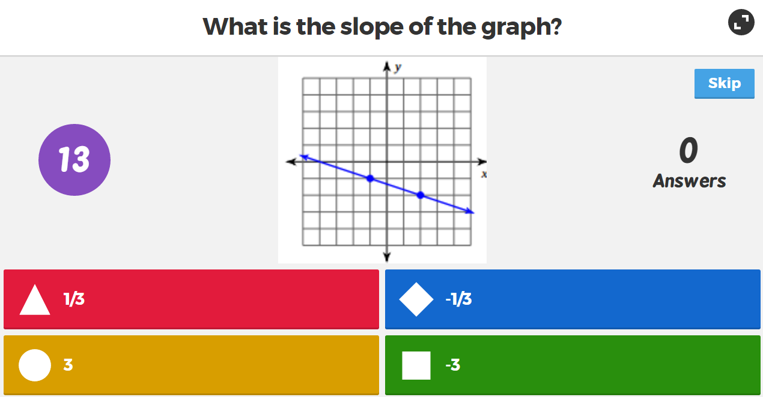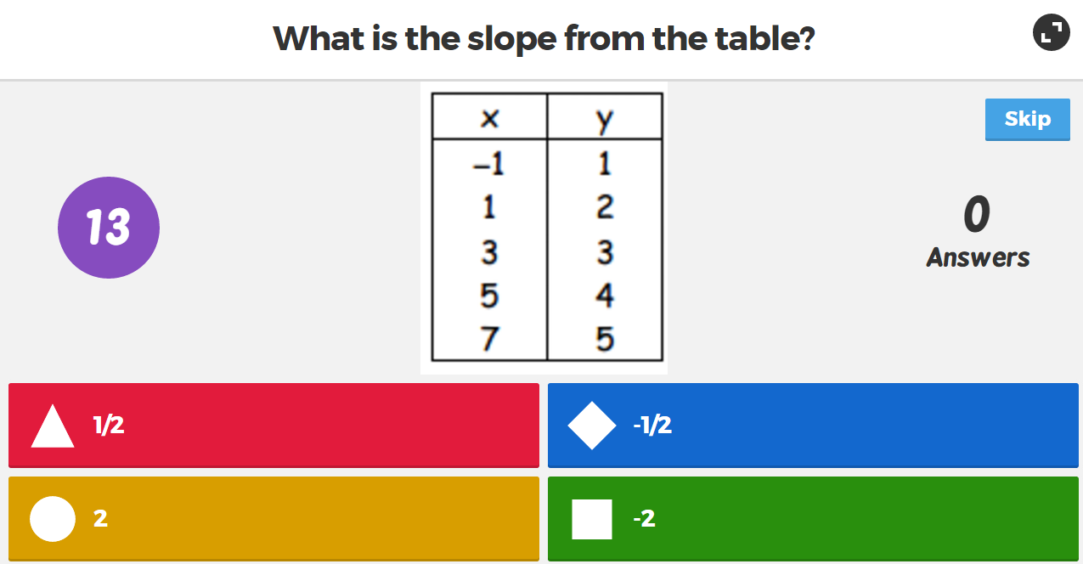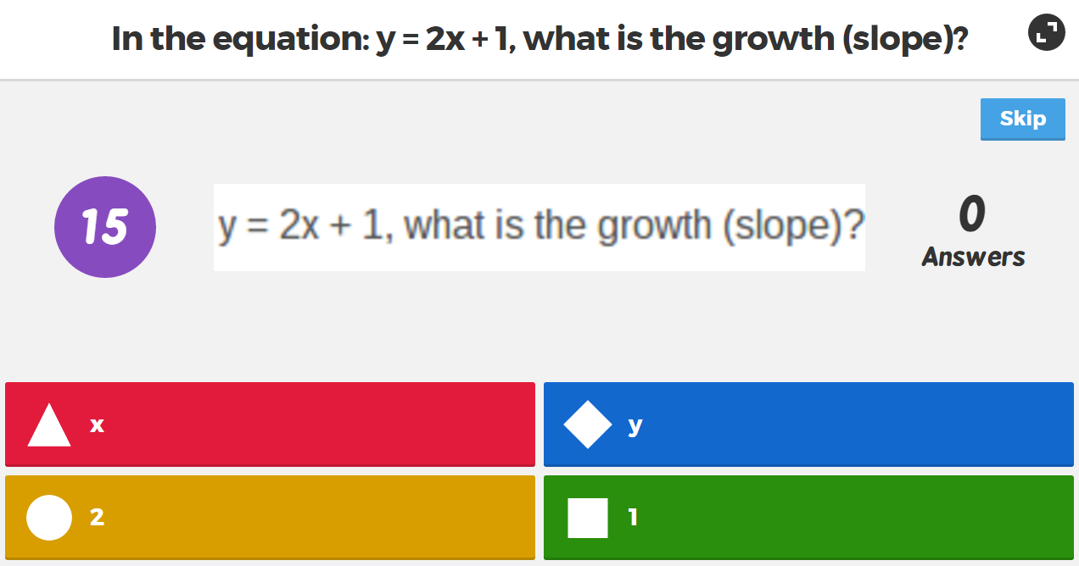

References:
GetKahoot.com Retrieved on 12/4/2015. Website: https://getkahoot.com/

https://create.kahoot.it/#public/kahoots?filter=1&tags=Algebra%20slope&audience=All
audiences&kahoots=all-kahoots&cursor=

